East Knox 25/26 Third Grade Supply List
Backpack (no wheels please) | 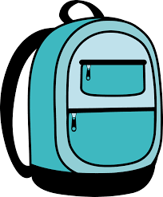 | 1 box of 24-count crayons | 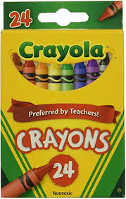
1 pair of sturdy Headphones with a microphone | 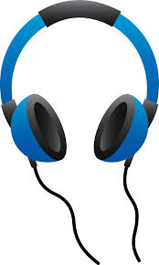 | 1 pack of color pencils | 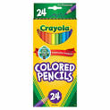
2 Composition Notebooks  * WIDE-RULED * | 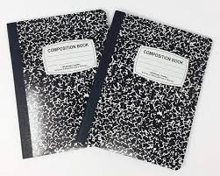 | 1 pencil pouch with zipper and 3 rings to fit in binder or pencil box | 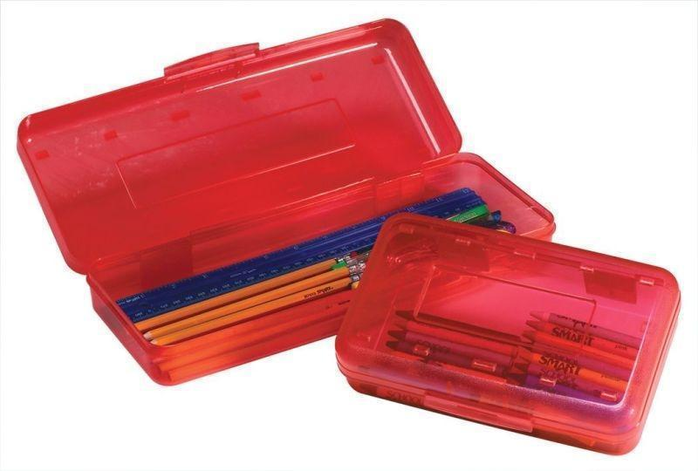  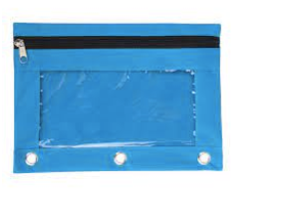
8 glue sticks | 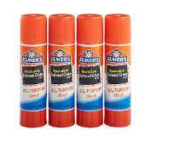 | 1 pack of cap erasers | 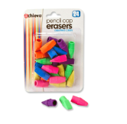
Multi-color pack of highlighters (at least 3 colors) | 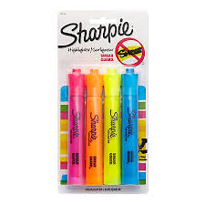 | 2 boxes (24 count) of yellow  No.2 Pencils  (Preferably sharpened) | 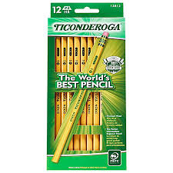
1 pair of Blunt-Tip Scissors | 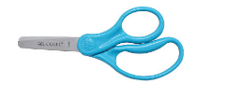 | 1 pack of *WIDE RULED*  Notebook Paper | 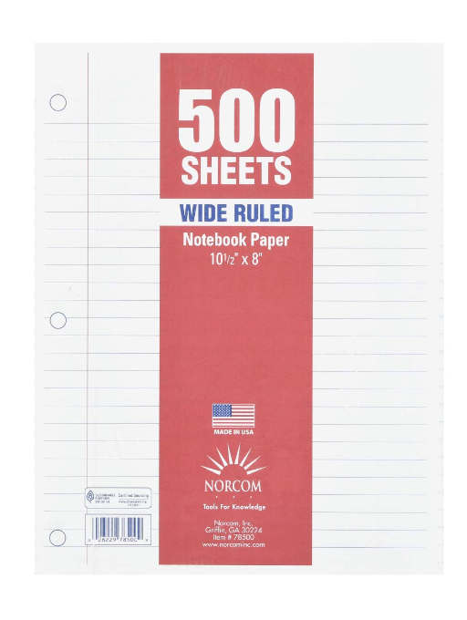
4 plastic folders with pockets and prongs (blue, green, red, orange) | 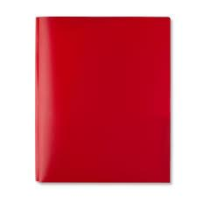 | 1 box of Kleenex | 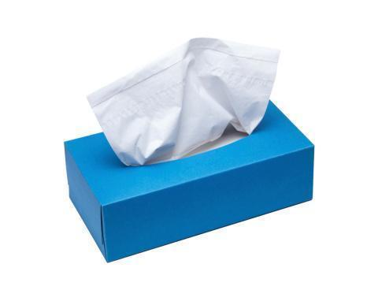
Three packs of 4 Black Dry-Erase Markers | 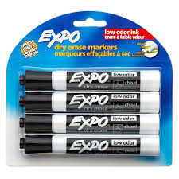 | 1 bottle of hand sanitizer with a pump | 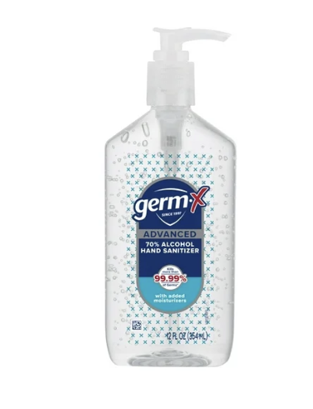
1 pack of Clorox Wipes | 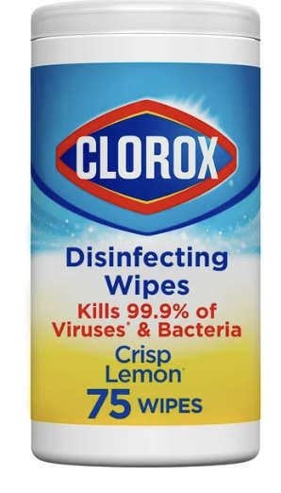 | 3 count large erasers | 